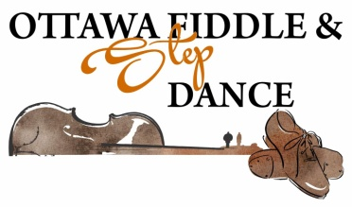
May 19th and 20th 2018, Richmond, Ontario

Dear ,

There are few things that make us feel better than hearing a well played fiddle tune or watching step shoes hit the floor with unbelievable rhythm and precision.

Once a year, fiddle players and dancers gather in our community to bring the music we love to life during our May long weekend competition. We ensure that musicians and dancers have a place to showcase their talents and receive recognition for their accomplishments. From our youngest fiddler to our oldest dancer, we provide a stage for the traditions that are woven into the fabric of this great country of ours.

That is why I am writing you today! We are living in a world that does not always place a priority on tradition and commitment to hard work . You can help us protect this artform for another generation. You can help determine who the fiddlers and dancers will be in the Canada of the future.

Your contribution means a great deal. We support those that support us! We search out those businesses and individuals who we recognize as sponsors of our competition. No donation goes unrecognized by those of us who are involved. We promote you! We support you! & We remember you!

Please take the time to make a donation to our organization today. The money that you contribute will be received by people who have worked extremely hard to earn their place at our event!

We will gratefully accept your contribution and give you our loyalty in return. You will never regret providing the money needed to keep this event successful. When this event succeeds, these musicians and dancers succeed.

Thank you,

Cassandra Greer
ottawafiddleandstepdance@gmail.com
President, OFSDA
ottawafiddlestepdance.weebly.com
613-978-3595

Please see the next page for details on contributions or call today if you have any questions

